vsMSSGateway Queue Enable/Disable Instructions

Overview:
This document is intended to provide a general explanation of the vsMSSGatewayDB service’s functionality and how to enable/disable some or all queues. The primary purpose of enabling/disabling queues is to have a warm standby system running in Union Gap. In the event of a disaster in Olympia, minimal configuration will be necessary to enable the warm standby to become the primary message processor for WSP inquiry and responses.

Assumptions:
In order for the standby system to be running in warm standby mode (i.e. – accepting messages from WSP but not writing the messages to the receiving queues), the warm standby and active instance of the service must each have their own instance of the vsMSSGateway database. This is necessary because the list of queues is defined in the database so both the active and standby instances of the service cannot point to the same instance of the database. The vsMSSGateway database contains primarily static information such as configuration values and ACCESS switch message-to-queue mapping. No transactional data is kept in the database.

Future Changes:
If new WSP messages are to be processed by the vsMSSGatewayDB service, typically a new mapping is added to the tblQueueList table in the vsMSSGateway database and the vsMSSGatewayDB service is cycled. This process would need to occur in the Union Gap instance of the vsMSSGateway database as well, except that the Disabled field for the queue would need to be set to “1”.

I. General Functionality.
Appendix A of this document contains a visual description of the flow outlined here. Upon startup of the vsMSSGatewayDB service, the instance of the service obtains its connection string from:

HKEY_LOCAL_MACHINE\SYSTEM\CurrentControlSet\Services\vsMSSGatewayDB\Parameters\DB Connect String

The service’s registry hive also contains the remote socket connection information. The information is kept with the service’s registry settings so multiple instances of the vsMSSGateway EXE can run in parallel, connecting to different sockets if necessary as was required pre-NMVTIS.

After obtaining the connection string from the registry, the service connects to the vsMSSGateway database and obtains the additional operating parameters such as the queue server and list of queues to process. The queue list is maintained in the tblQueueList table.

Next, service will establish a connection to the WSP ACCESS switch via the TCP socket (Remote Port and Remote Server) parameters defined in the registry. Messages received from the ACCESS switch are normally placed in the appropriate queue to be processed by a subsequent process. Any responses to be returned to the WSP will be placed in a common outgoing queue labeled DBQTx by the subsequent processes. The vsMSSGatewayDB service will monitor the DBQTx queue and retrieve messages from that queue and send them to the WSP ACCESS switch.

If the “Disabled” field for a queue in the tblQueueList is zero (0), the service will process messages normally for that queue. If the “Disabled” field for a queue is one (1), messages destined for that queue will be ignored. Although there may be multiple message keys mapped to a single queue and each has its own “Disabled” field, enabling/disabling must occur at the queue level. So, either all message keys for a particular queue should be marked as enabled or all message keys for a particular queue should be marked as disabled. Marking some message keys as enabled and some for disabled for the same queue will not provide correct results. SQL scripts have been provided which will enable/disable one or all queues appropriately. These scripts are also included in Appendix B.

If all queues in the tblQueueList have the “Disabled” field set to one, the vsMSSGatewayDB service will also ignore any messages in the DBQTx queue.

II. Suggested Steps for Enabling/Disabling a Queue.
The steps to have the warm standby begin actively processing one or more queues would be as follows:
- Identify the queue(s) that will be processed by Union Gap.
- Using the vsMSSGateway_Enable_Disable_queue_script.sql script, set the @Disabled parameter to zero (0) and the @QueueLabel parameter to the label of the queue. Run the script against the Union Gap vsMSSGateway database.
- Using the vsMSSGateway_Enable_Disable_queue_script.sql script, set the @Disabled parameter to one (1) and the @QueueLabel parameter to the label of the queue. Run the script against the Olympia vsMSSGateway database.
- Cycle the vsMSSGatewayDB service in Union Gap. Union Gap will now process the queue.
- Cycle the vsMSSGatewayDB service in Olympia. Olympia will now ignore the queue messages.

Note – if the vsMSSGatewayDB service in Union Gap and the vsMSSGatewayDB service in Olympia share the same queue server, both instances will be monitoring the same common DBQTx queue for messages to be sent back to WSP. The original design of the vsMSSGatewayDB supports condition. However it is worth noting that a message received from WSP via the Olympia socket connection could be returned to WSP via the Union Gap socket connection.

III. Suggested Steps for Disaster Recovery Mode.
In the event of a disaster in Olympia, the general steps to activate the warm standby would be as follows:
- Run the vsMSSGateway_ENABLE_all_queues.SQL script on the vsMSSGateway database in Union Gap.
- Cycle the vsMSSGatewayDB service in Union Gap. At this point, the vsMSSGatewayDB service in Union Gap would be able to process all messages for WSP. Note – the subsequent DOL services that monitor the various queues would also need to be activated in Union Gap.
- Run the vsMSSGateway_DISABLE_all_queues.SQL script on the vsMSSGateway database in Olympia (if possible).
- Cycle the vsMSSGatewayDB service in Olympia (if possible).

Appendix A: Overview Diagram

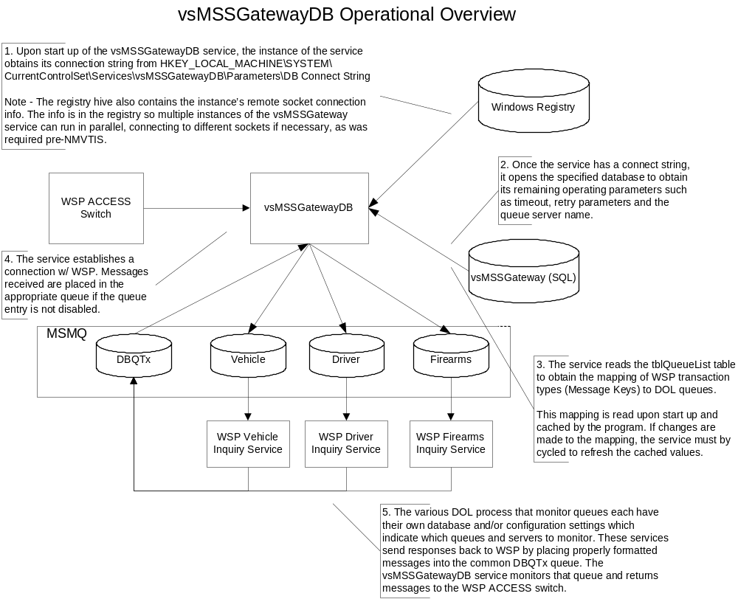

Appendix B: SQL Scripts
-- vsMSSGateway_DISABLE_all_queues.SQL
use vsMSSGateway
go
/*
This script will mark all queues as disabled. This should be run on the standby instance of the vsMSSGateway database unless in disaster recovery mode. The vsMSSGatewayDB service only reads the database upon startup. Therefore, the vsMSSGatewayDB service MUST be recycled after running this script for it to be effective.

Also, the vsMSSGateway_ENABLE_all_queues.SQL script should be run on the non-standby instance of the vsMSSGateway database and the non-standby vsMSSGatewayDB service should be recycled.
*/
update tblQueueList
set Disabled = 1
/* Step 2 - Show the results */
select * from tblQueueList
order by QueueLabel asc
go

-- vsMSSGateway_ENABLE_all_queues.SQL
use vsMSSGateway
go
/*
This script will mark all queues as enabled. This should be run on the active instance of the vsMSSGateway database unless in disaster recovery mode. The vsMSSGatewayDB service only reads the database upon startup. Therefore, the vsMSSGatewayDB service MUST be recycled after running this script for it to be effective.

Also, the vsMSSGateway_DISABLE_all_queues.SQL script should be run on the standby instance of the vsMSSGateway database and the standby vsMSSGatewayDB service should be recycled.
*/
update tblQueueList
set Disabled = 0

/* Step 2 - Show the results */
select * from tblQueueList
order by QueueLabel asc
go

-- vsMSSGateway_Enable_Disable_queue_script.sql
use vsMSSGateway
go
declare @Disabled tinyint
declare @QueueLabel varchar(20)
-- set this value to the label of the queue being enabled/disabled.
-- select distinct queuelabel from tblQueueList
set @QueueLabel = ''
/*
Toggle the @Disabled value between zero (0) and one (1).
When zero, the queue is processed normally (i.e. - not disabled).
When one, messages destined for this queue are ignored (i.e. - standby mode).
*/
set @Disabled = 0
/*
No need to modify anything below here
Step 1 - Update the Disabled bit
*/
update tblQueueList
set Disabled = @Disabled
where QueueLabel = @QueueLabel

/* Step 2 - Show the results */
select * from tblQueueList
where QueueLabel = @QueueLabel
order by QueueLabel asc
go

Appendix C – Testing

Because the vsMSSGatewayDB service is one element in a system of comprised of multiple asynchronous processes working together, compounded by the limited test environment of the WSP ACCESS switch, performing unit tests of the vsMSSGatewayDB service can be challenging. To facilitate testing, a stand-alone ACCESS Switch Simulator program has been created and can be found at \\DOLWBOLYVSDEV1\VSCOM\Install\vsMSSGatewayDB\Access_Simulator\.

The ACCESS Simulator is a simple standalone VB6 socket server listener program that accepts a connection attempt from the vsMSSGatewayDB service. When connected, the user can enter inquiry strings. These inquiry requests simulate a WSP Terminal submitting an inquiry to DOL through the WSP ACCESS switch and vsMSSGatewayDB service. The inquiry will be written to the appropriate receiving queue on the DOL side. If the subsequent queue process is also running and monitoring the queue, the inquiry is read from the queue and a return response is placed in the common outgoing queue (DBQTx). The vsMSSGatewayDB service retrieves the message from the DBQTx and returns the message to the ACCESS Simulator program.

To use the ACCESS Simulator, copy it to the desired location on the target server (typically, this should be the same server as the vsMSSGatewayDB since the ACCESS Simulator uses the Mabry Socket/X ActiveX socket control.

When the ACCESS Simulator program is started, a prompt is displayed. Enter the port and IP address that the ACCESS Simulator program should listen for incoming connection requests. The IP should be the actual IP of the machine running the program. The port can be any unused TCP Port but 1000 is suggested since that is the port number used by the actual ACCESS switch. The simulator begins listening for incoming connection requests.

Next, open the Registry key HKEY_LOCAL_MACHINE\SYSTEM\CurrentControlSet\Services\vsMSSGatewayDB\Parameters. Set the “Remote Port” and “Remote Server” keys to the values that the ACCESS Simulator is using. Start the vsMSSGatewayDB service. The vsMSSGatewayDB service should establish a connection to the ACCESS Simulator. When the connection is established, the ACCESS Simulator will display a screen that allows an inquiry string to be submitted to the vsMSSGatewayDB service. A textbox includes some sample inquiry strings.
As mentioned above, for a complete end-to-end test, the subsequent queue process must be running and properly configured in order to read the inquiry from the receiving queue and write a response to the common DBQTx return queue. However, using Windows Computer Management utility, a test of the vsMSSGatewayDB service can be performed by verifying that an inquiry request results in a message being delivered to the appropriate receiving queue. To simulate a response, use the QueueWrite.exe utility to write a message directly into the DBQTx queue. The vsMSSGatewayDB will return the test message back to the ACCESS Simulator. The QueueWrite.exe can also be found in the same folder as the ACCESS Simulator.

Tip – if the vsMSSGatewayDB fails to connect to the ACCESS Simulator, review the Windows Application Event log for socket connection attempt errors to aid in troubleshooting.

